ASSIGNMENT 5

AIM:
Implement Quick Sort to sort the given list of numbers. Display corresponding list in each pass.

OBJECTIVE:
The objective of this program is to learn Quick sort method and print it pass wise.

THEORY:
Quick Sort:
Quicksort is an efficient sorting algorithm, serving as a systematic method for
placing the elements of a random access file or an array in order.

CODE:

#include<bits/stdc++.h>
using namespace std;
int partition(int *a,int start,int end)
{
int pivot=a[end];
int P_index=start;
int i,t;
for(i=start;i<end;i++)
{
if(a[i]<=pivot)
{
t=a[i];
a[i]=a[P_index];
a[P_index]=t;
P_index++;
}
}
t=a[end];
a[end]=a[P_index];
a[P_index]=t;
return P_index;
}
void Quicksort(int *a,int start,int end)
{
if(start<end)
{
int P_index=partition(a,start,end);
Quicksort(a,start,P_index-1);
Quicksort(a,P_index+1,end);
}
}
int main()
{
int n;
cout<<"Enter number of elements: ";
cin>>n;
int a[n];
cout<<"Enter the array elements:\n";
for(int i=0;i<n;i++)
{
cin>>a[i];
}
Quicksort(a,0,n-1);
cout<<endl<<"After Quick Sort the array is:\n";
for(int i=0;i<n;i++)
{
cout<<a[i]<<" ";
}

cout<<endl;
return 0;
}

OUTPUT:
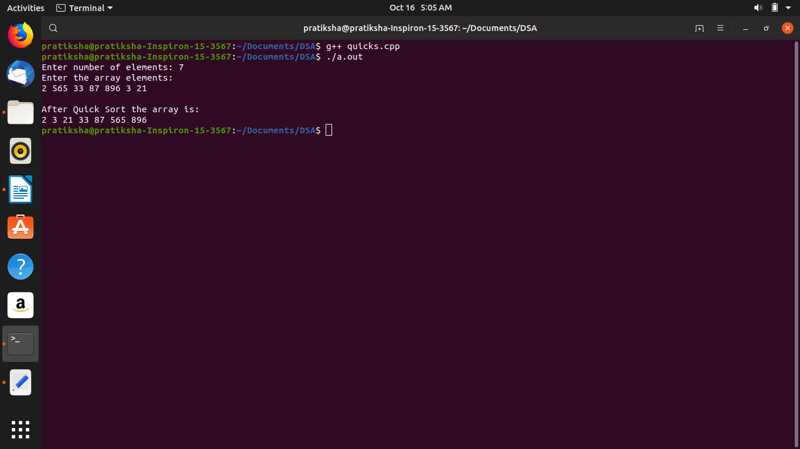

COMPLEXITY:
n*(log n)

CONCLUSION:
We learnt how to implement Quick sort method.
Last modified: 7:21 am

